**Task 1:**

Create a code to display

“Hello guys!!!! “

“We are learning Java”

Using a single output statement…  
  
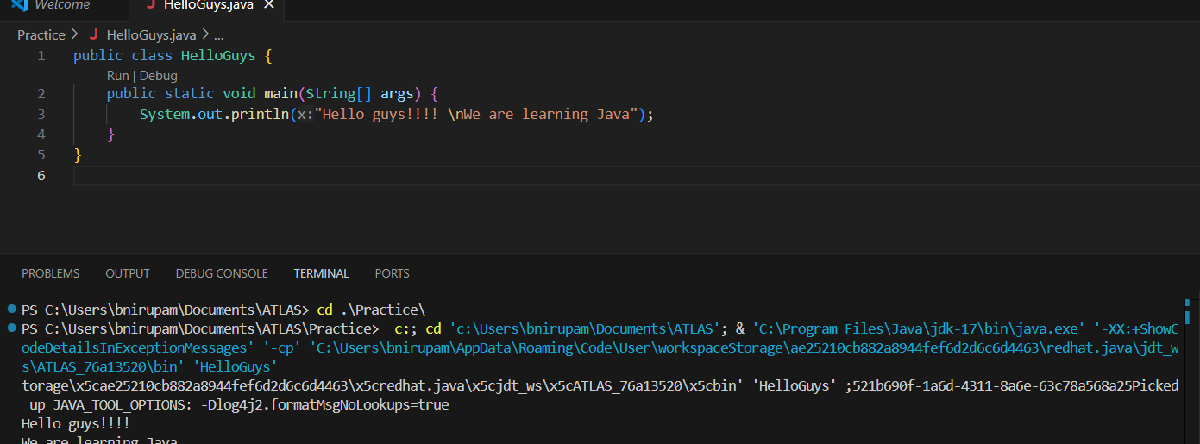**Task 2:**

 Write a Program in Java to Add two Numbers.

Input: 2 3

Output: 5

import java.util.Scanner;

public class Task02 {

    public static void main(String[] args) {

        Scanner input = new Scanner(System.in);

        int a = input.nextInt();

        int b = input.nextInt();

        int sum = a + b;

        System.out.println(sum);

    }

}

**Task 003:**

Write a Program to Swap Two Numbers

Input: a=2  b=5

Output: a=5  b=2

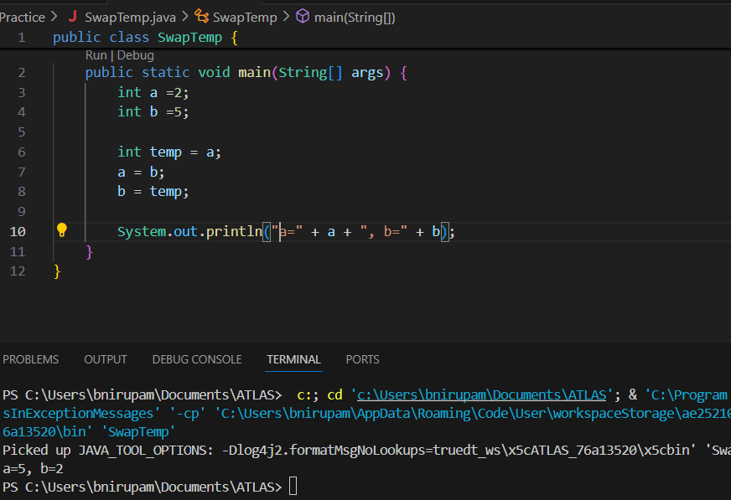

**Task 04:**

Create a code in which you have 4 methods add, subtract, multiply and divide (return type int) with a main method to all the other methods

Out put:

Main started

Sum of 2 numbers is …..

Diff of 2 numbers is —-

Product of 2 numbers ….

Division of 2 numbers is ….

Main ended

public class Task04_Calculator {

    public static int add(int num1, int num2) {

        return num1 + num2;

    }

    public static int subtract(int num1, int num2) {

        return num1 - num2;

    }

    public static int multiply(int num1, int num2) {

        return num1 * num2;

    }

    public static int divide(int num1, int num2) {

        if (num2 == 0) {

            System.out.println("Error: Cannot divide by zero!");

            return 0;

        }

        return num1 / num2;

    }

    public static void main(String[] args) {

        System.out.println("Main started");

        int num1 = 10, num2 = 5;

        System.out.println("Sum of " + num1 + " and " + num2 + " is " + Task04_Calculator.add(num1, num2));

        System.out.println("Diff of " + num1 + " and " + num2 + " is " + Task04_Calculator.subtract(num1, num2));

        System.out.println("Product of " + num1 + " and " + num2 + " is " + Task04_Calculator.multiply(num1, num2));

        System.out.println("Division of " + num1 + " and " + num2 + " is " + Task04_Calculator.divide(num1, num2));

        System.out.println("Division of " + num1 + " and 0 is " + Task04_Calculator.divide(num1, 0));

        System.out.println("Main ended");

    }

}

**Task 005:**

Write a program to check if a is greater or b.. Use ternary op

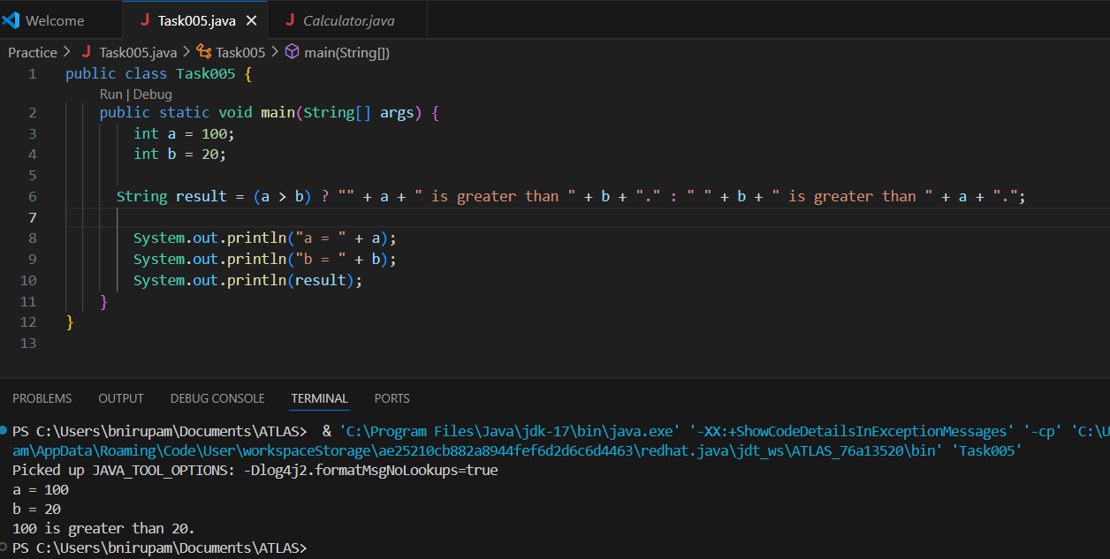

**Task 006:**

Write a program to take input from the user and display it to the user

Input:

Id : Prasunamba

Pwd: 123456789

Output:

Hi ,

  Your login id is Prasuanmba

And your pwd is *********

import java.util.Scanner;

public class Task006 {

    public static void main(String[] args) {

        Scanner scanner = new Scanner(System.in);

        System.out.println("Hello! Please enter your Login ID:");

        String loginID = scanner.nextLine();

        System.out.println("Please enter your Password:");

         String Password = scanner.nextLine();

        System.out.println("Hi");

        System.out.println("Your Login ID is: " + loginID);

        System.out.println("And your Password is "  + Password);

        scanner.close();

    }

}

**Task 007:**

Write a program to create a class named Customer

Call the customer class in Task007 class using an object

import java.util.Scanner;

public class Customer {

public static void main(String[] args) {

        Scanner scanner = new Scanner(System.in);

        System.out.println("Hello! Please enter your Login ID:");

        String loginID = scanner.nextLine();

        System.out.println("Please enter your Password:");

         String Password = scanner.nextLine();

        System.out.println("Hi");

        System.out.println("Your Login ID is: " + loginID);

        System.out.println("And your Password is "  + Password);

        scanner.close();

    }

}

public class Task007 {

     public static void main(String[] args) {

     Customer.main(new String[]{});

    }

}

**Task 008:**

Wap to check the greater of 2 numbers

Hint:

Use if else

If ( num1 > num2){

sout(“num1 is greater”);

}

Else {

sout(“num2 is greater”);

}

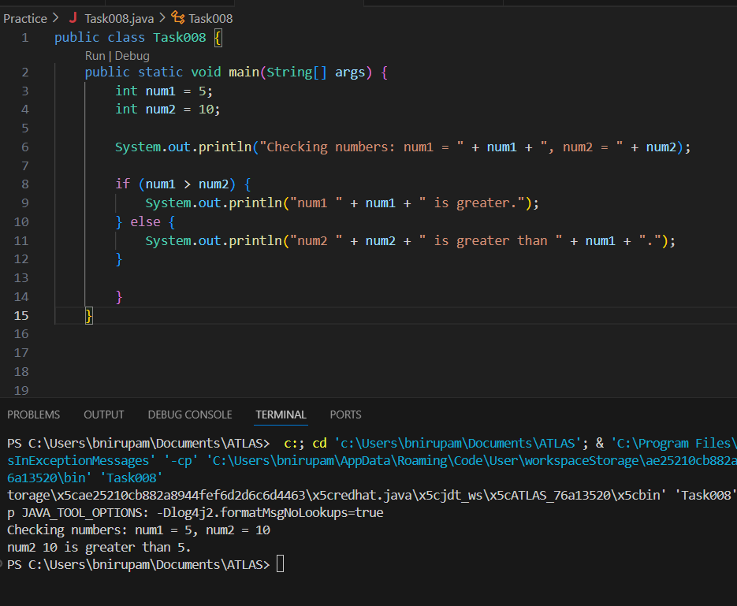

Task 009

Wap to check greater of 3 numbers

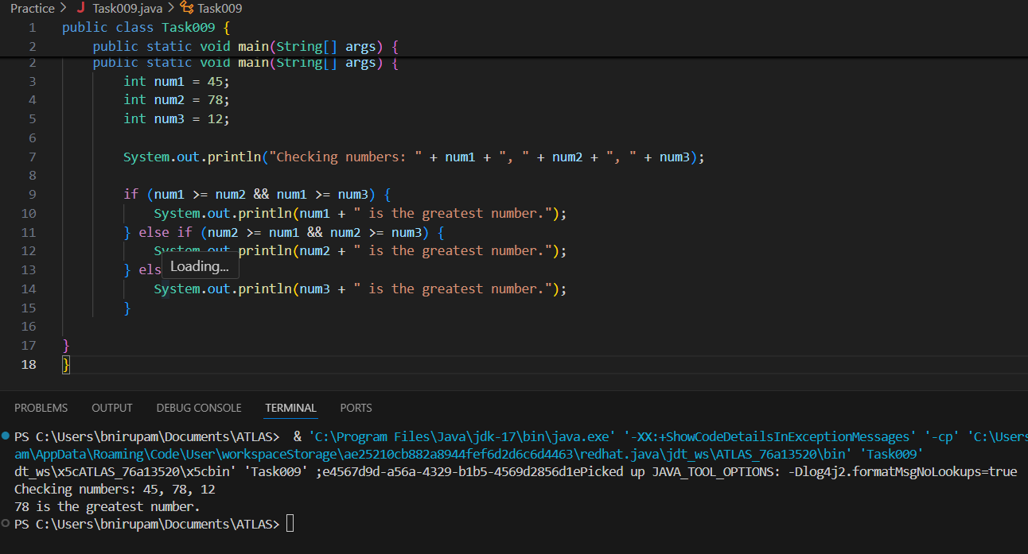

**Task 010:**

Wap to check if check week days

1  ===> sunday

2 ===> monday

So on

8 and above ===> invalid input

Hint : use Switch case

import java.util.Scanner;

public class Task010 {

    public static void main(String[] args) {

        Scanner scanner = new Scanner(System.in);

        System.out.println("Enter the day number");

        int dayNumber = scanner.nextInt();

        String dayName = switch (dayNumber) {

            case 1 -> "Sunday";

            case 2 -> "Monday";

            case 3 -> "Tuesday";

            case 4 -> "Wednesday";

            case 5 -> "Thursday";

            case 6 -> "Friday";

            case 7 -> "Saturday";

            default -> "Invalid Input";

        };

        System.out.println(dayNumber + " is " + dayName);

}

}

**Task 011:**

Wap to check loginid and password validation

Hint use while loop

import java.util.Scanner;

public class Task011 {

    public static void main(String[] args) {

        String correctLoginID = "bnirupam";

        String correctPassword = "password123";

        Scanner scanner = new Scanner(System.in);

        boolean isAuthenticated = false;

        while (!isAuthenticated) {

            System.out.println("\nPlease enter your Login ID:");

            String enteredLoginID = scanner.nextLine();

            System.out.println("Please enter your Password:");

            String enteredPassword = scanner.nextLine();

            if (enteredLoginID.equals(correctLoginID) && enteredPassword.equals(correctPassword)) {

                isAuthenticated = true;

                System.out.println("\nLogin Successful! Welcome, " + enteredLoginID + ".");

            } else {

                System.out.println("\nInvalid Login ID or Password. Please try again.");

            }

        }

        scanner.close();

    }

}

**Task 012:**

Same as above qn but use do while loop

import java.util.Scanner;

public class Task012 {

    public static void main(String[] args) {

        final String CORRECT_LOGIN_ID = "bnirupam";

        final String CORRECT_PASSWORD = "12345867";

        Scanner sc = new Scanner(System.in);

        String enteredLoginId;

        String enteredPassword;

        int count = 0;

        do{

            System.out.println("Please enter your Login ID:");

            enteredLoginId = sc.nextLine();

            System.out.println("Please enter your Password:");

            enteredPassword = sc.nextLine();

            if (!enteredLoginId.equals(CORRECT_LOGIN_ID) || !enteredPassword.equals(CORRECT_PASSWORD)) {

                System.out.println("Invalid Login ID or Password. Please try again.");

            }

            count++;

        } while (!enteredLoginId.equals(CORRECT_LOGIN_ID) || !enteredPassword.equals(CORRECT_PASSWORD));

        System.out.println("\nLogin Successful! Welcome, " + enteredLoginId + ".");

        sc.close();

    }

}

**Task013:**

Wap to display numbers from 10 to 1 .. skip 7 and 5.

for(int i= 10; i >0; i–){

If ( i == 5 || i == 7){

Continue;

sout(i);

}

public class Task013 {

    public static void main(String[] args) {

        for (int i = 10; i > 0; i--) {

            if (i == 5 || i == 7) {

                continue;

            }

            System.out.println(i);

        }

    }

}

Task 014:

Arrays:

Try the below code and display the output…

Now play with it try to access 5th index and see the output…and try to access -1 index and see the output..

package Arrays;

public class Demo01 {

public static void main(String[] args) {

// TODO Auto-generated method stub

char[] arr = {'a','e','i','o','u'};

System.out.println(arr);

String[] names = {"Meena", "Tina", "Veena", "heena"};

System.out.println(names[0]);

names[1]= "Reena";

System.out.println(names[1]);

System.out.println(names.length);

System.out.println(names[4]);

//Exception in thread "main" java.lang.ArrayIndexOutOfBoundsException

}

}

Strings:

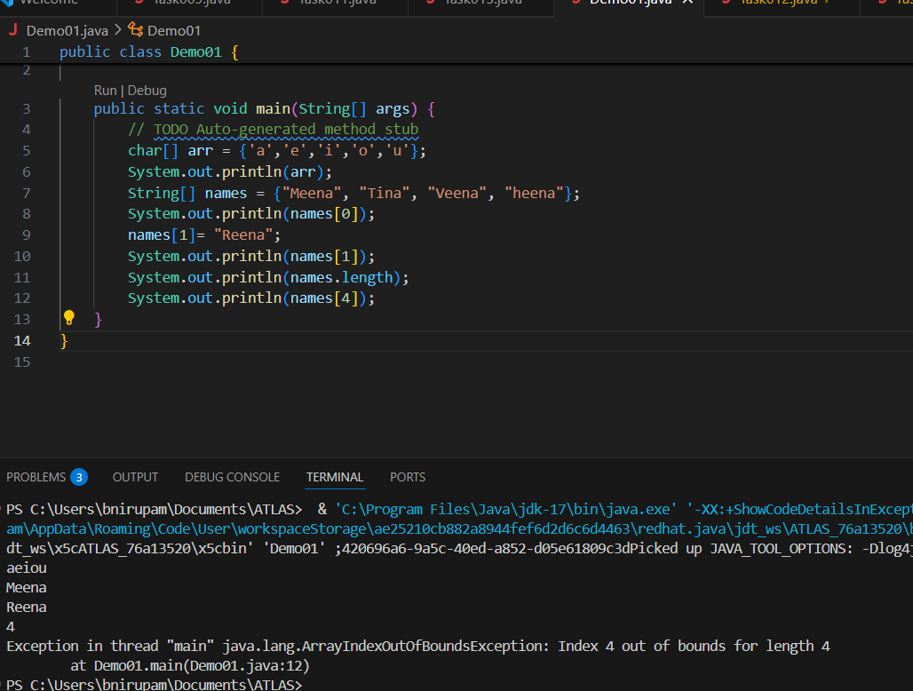

Task 015:

package StringHandling;

public class Demo01 {

public static void main(String[] args) {

// TODO Auto-generated method stub

String str1 = "Java Strings "; // string Literal

String str2 = new String(str1); // obj of the string - new keyword

String str3 = new String("are easy to learn ");

char ch[] = {'S', 't', 'r' ,'i', 'n', 'g'};

String str4 = new String(ch);

System.out.println(str1 + "\n" + str2 + "\n" +str3 + "\n" +str4);

}

}

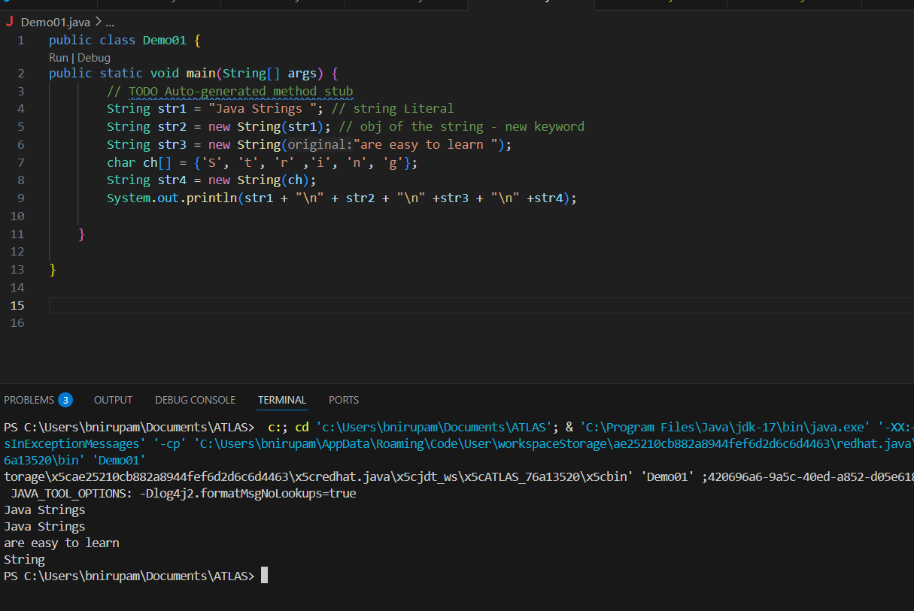

**Task 016**

Enums or Enumerations

What is the output of the below code snippet

package Enumerations;

enum color{

red, blue, green, yellow

}

public class Demo01 {

public static void main(String[] args) {

color c1 = color.yellow;

System.out.println(c1);

}

}

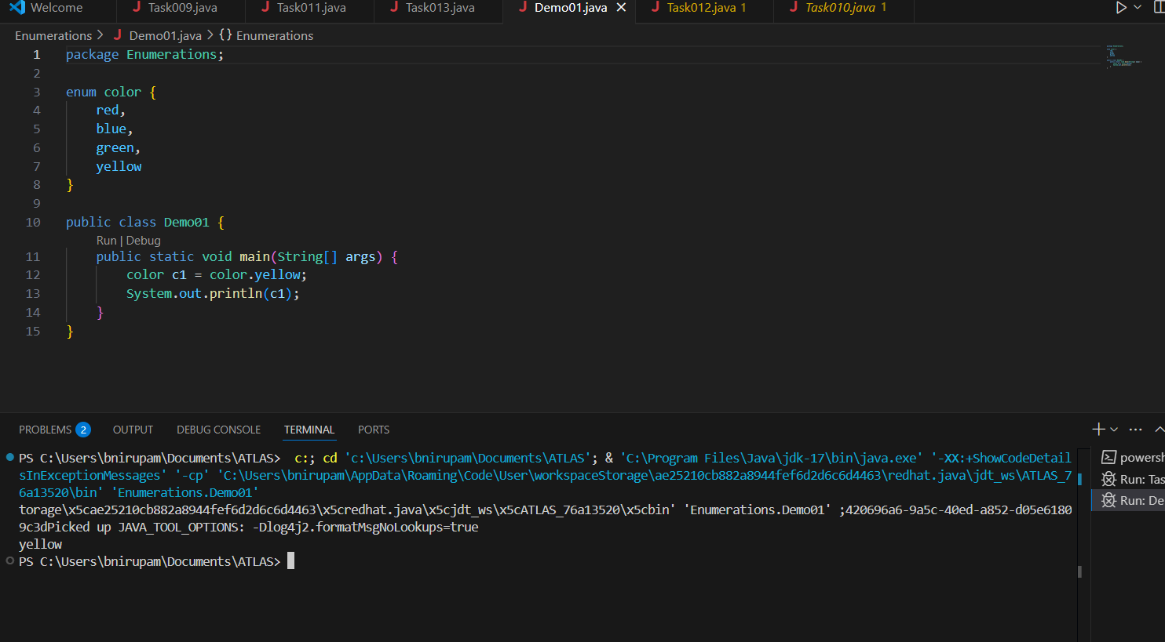

**Task 017:**

Getter and setter

Create a program name Person.java

public class Person {

   private String name;

   // Getter

   public String getName() {

     return name;

   }

   // Setter

   public void setName(String newName) {

     this.name = newName;

   }

}

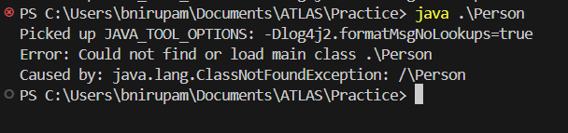

Create another program named Task017.java

public class Task017{

  public static void main(String[] args) {

    Person myObj = new Person();

    myObj.name = "John";

    System.out.println(myObj.name);

  }

}

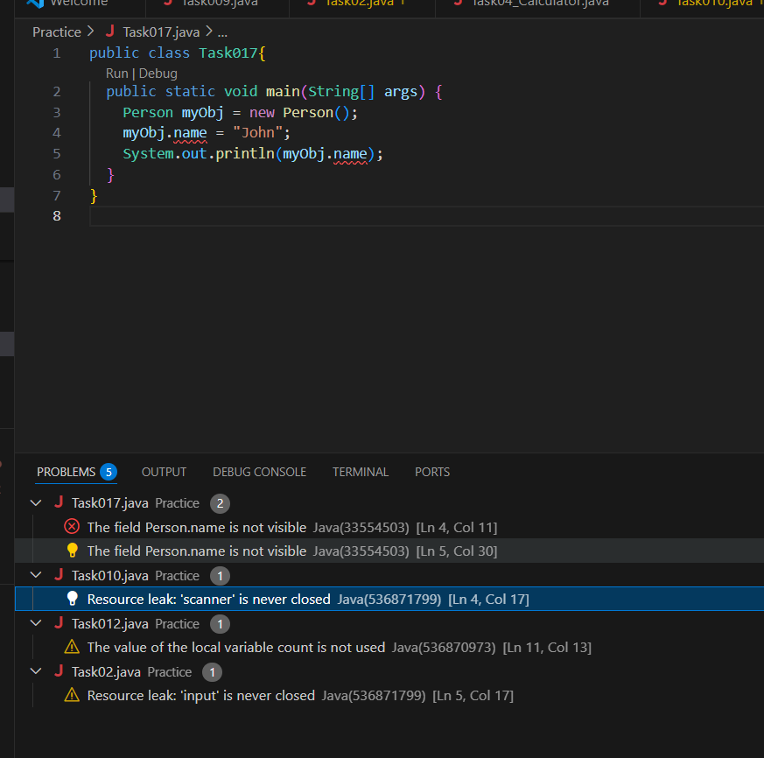

The name field is declared as private, which means it can **only be accessed within the Person class itself**.

We're trying to access it **directly** from another class (Task017), which is not allowed.

**Task 018**

Now create one more program named Task018.java

public class Main {

  public static void main(String[] args) {

    Person myObj = new Person();

    myObj.setName("John");

    System.out.println(myObj.getName());

  }

}

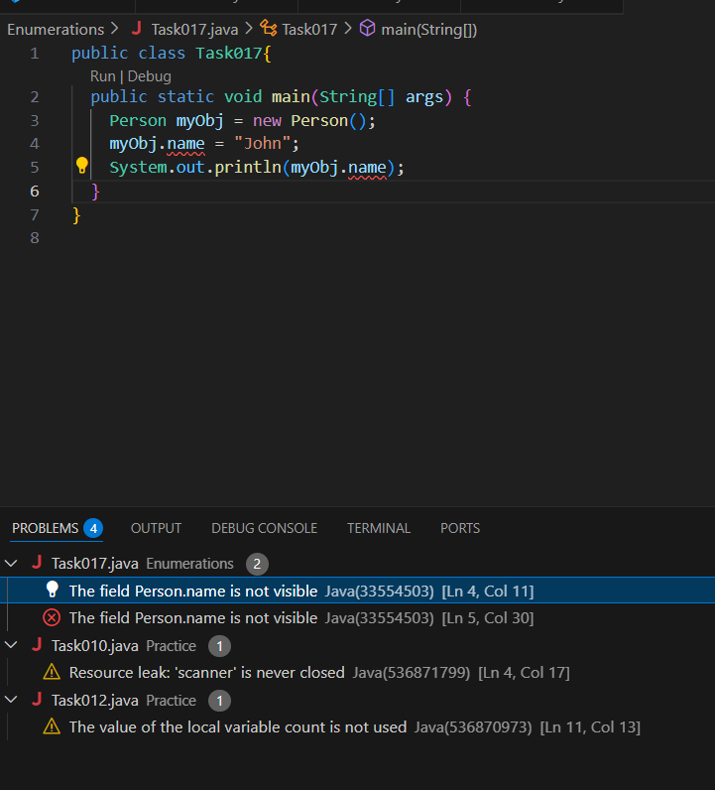

**Task 018**

Now create one more program named Task018.java

public class Main {

  public static void main(String[] args) {

    Person myObj = new Person();

    myObj.setName("John");

    System.out.println(myObj.getName());

  }

}

